Report listing page should not be open when continue as guest
Add to favorite should redirect to login page when open the specific listing.
Welcome text should be in center in login page.
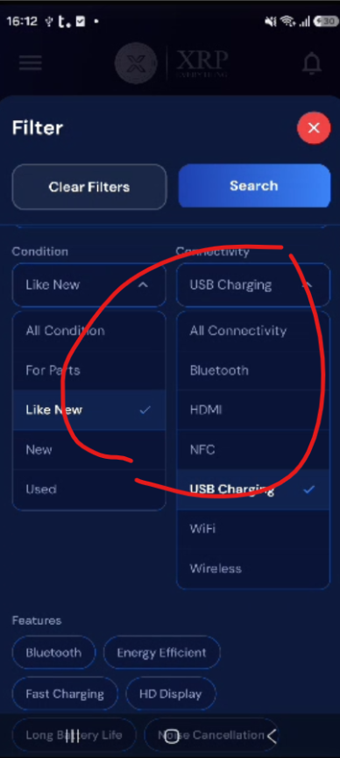

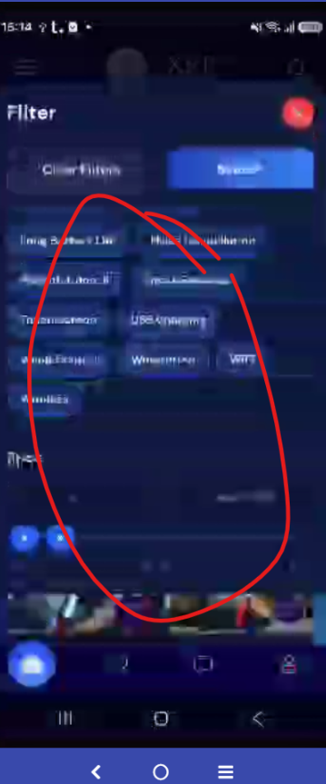
Broken when continue as guest, then open the filter and click on location
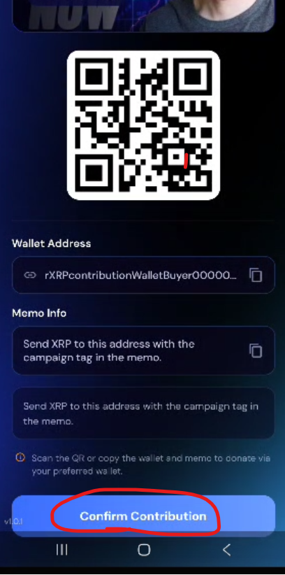
should redirect to login page
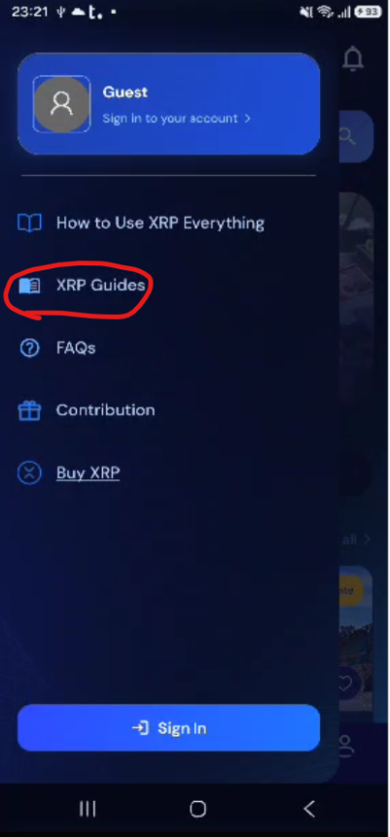
Should redirect to XRP Guide page

